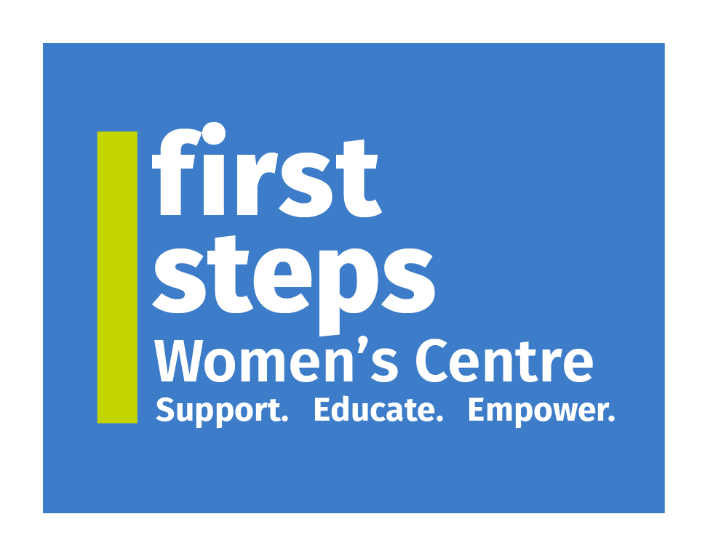 | Application Form for Voluntary Director
First Steps Women’s Centre | 21a William Street, Dungannon, Co. Tyrone | Tel: (028) 8772 7648 Please return application via Email: fswc.recruitment@gmail.com
Closing Date: Friday 10th October 2025

Section 1: Personal Details
Full Name:
Address:
Telephone (Home):
Telephone (Mobile):
Email:
NI Number (optional):

Section 2: Relevant Skills and Experience
Please tick all areas where you have experience or knowledge:
☐ | Community Development
☐ | Financial Management
☐ | Marketing
☐ | Fundraising
☐ | Strategic Planning
☐ | Policy Development
☐ | Other – Please state
Please describe any relevant voluntary/community/board roles or relevant qualifications:

Section 3: Employment Record (Last 5 Years)
Employer | Position Held | Dates (From–To) | Brief Description of Duties

Section 4: Your Motivation
Why are you interested in becoming a Director at FSWC?

How do you think your skills and experience will contribute to our work?

Section 5: References
Please provide the name, address, occupation and contact details of two referees (not related to you and known for at least 2 years):
Referee 1 | Referee 2
Name:  Address:  Occupation:  Contact Details: | Name:  Address:  Occupation:  Contact Details:

Section 6: Declarations
Do you have any conflicts of interest to declare? ☐ Yes ☐ No
Have you ever been convicted of a criminal offence (other than those considered spent)? ☐ Yes ☐ No
If yes, please provide details:

I declare that the information I have given is correct.
Signed: ________________________________ Date: __________________
Print Name: _____________________________

