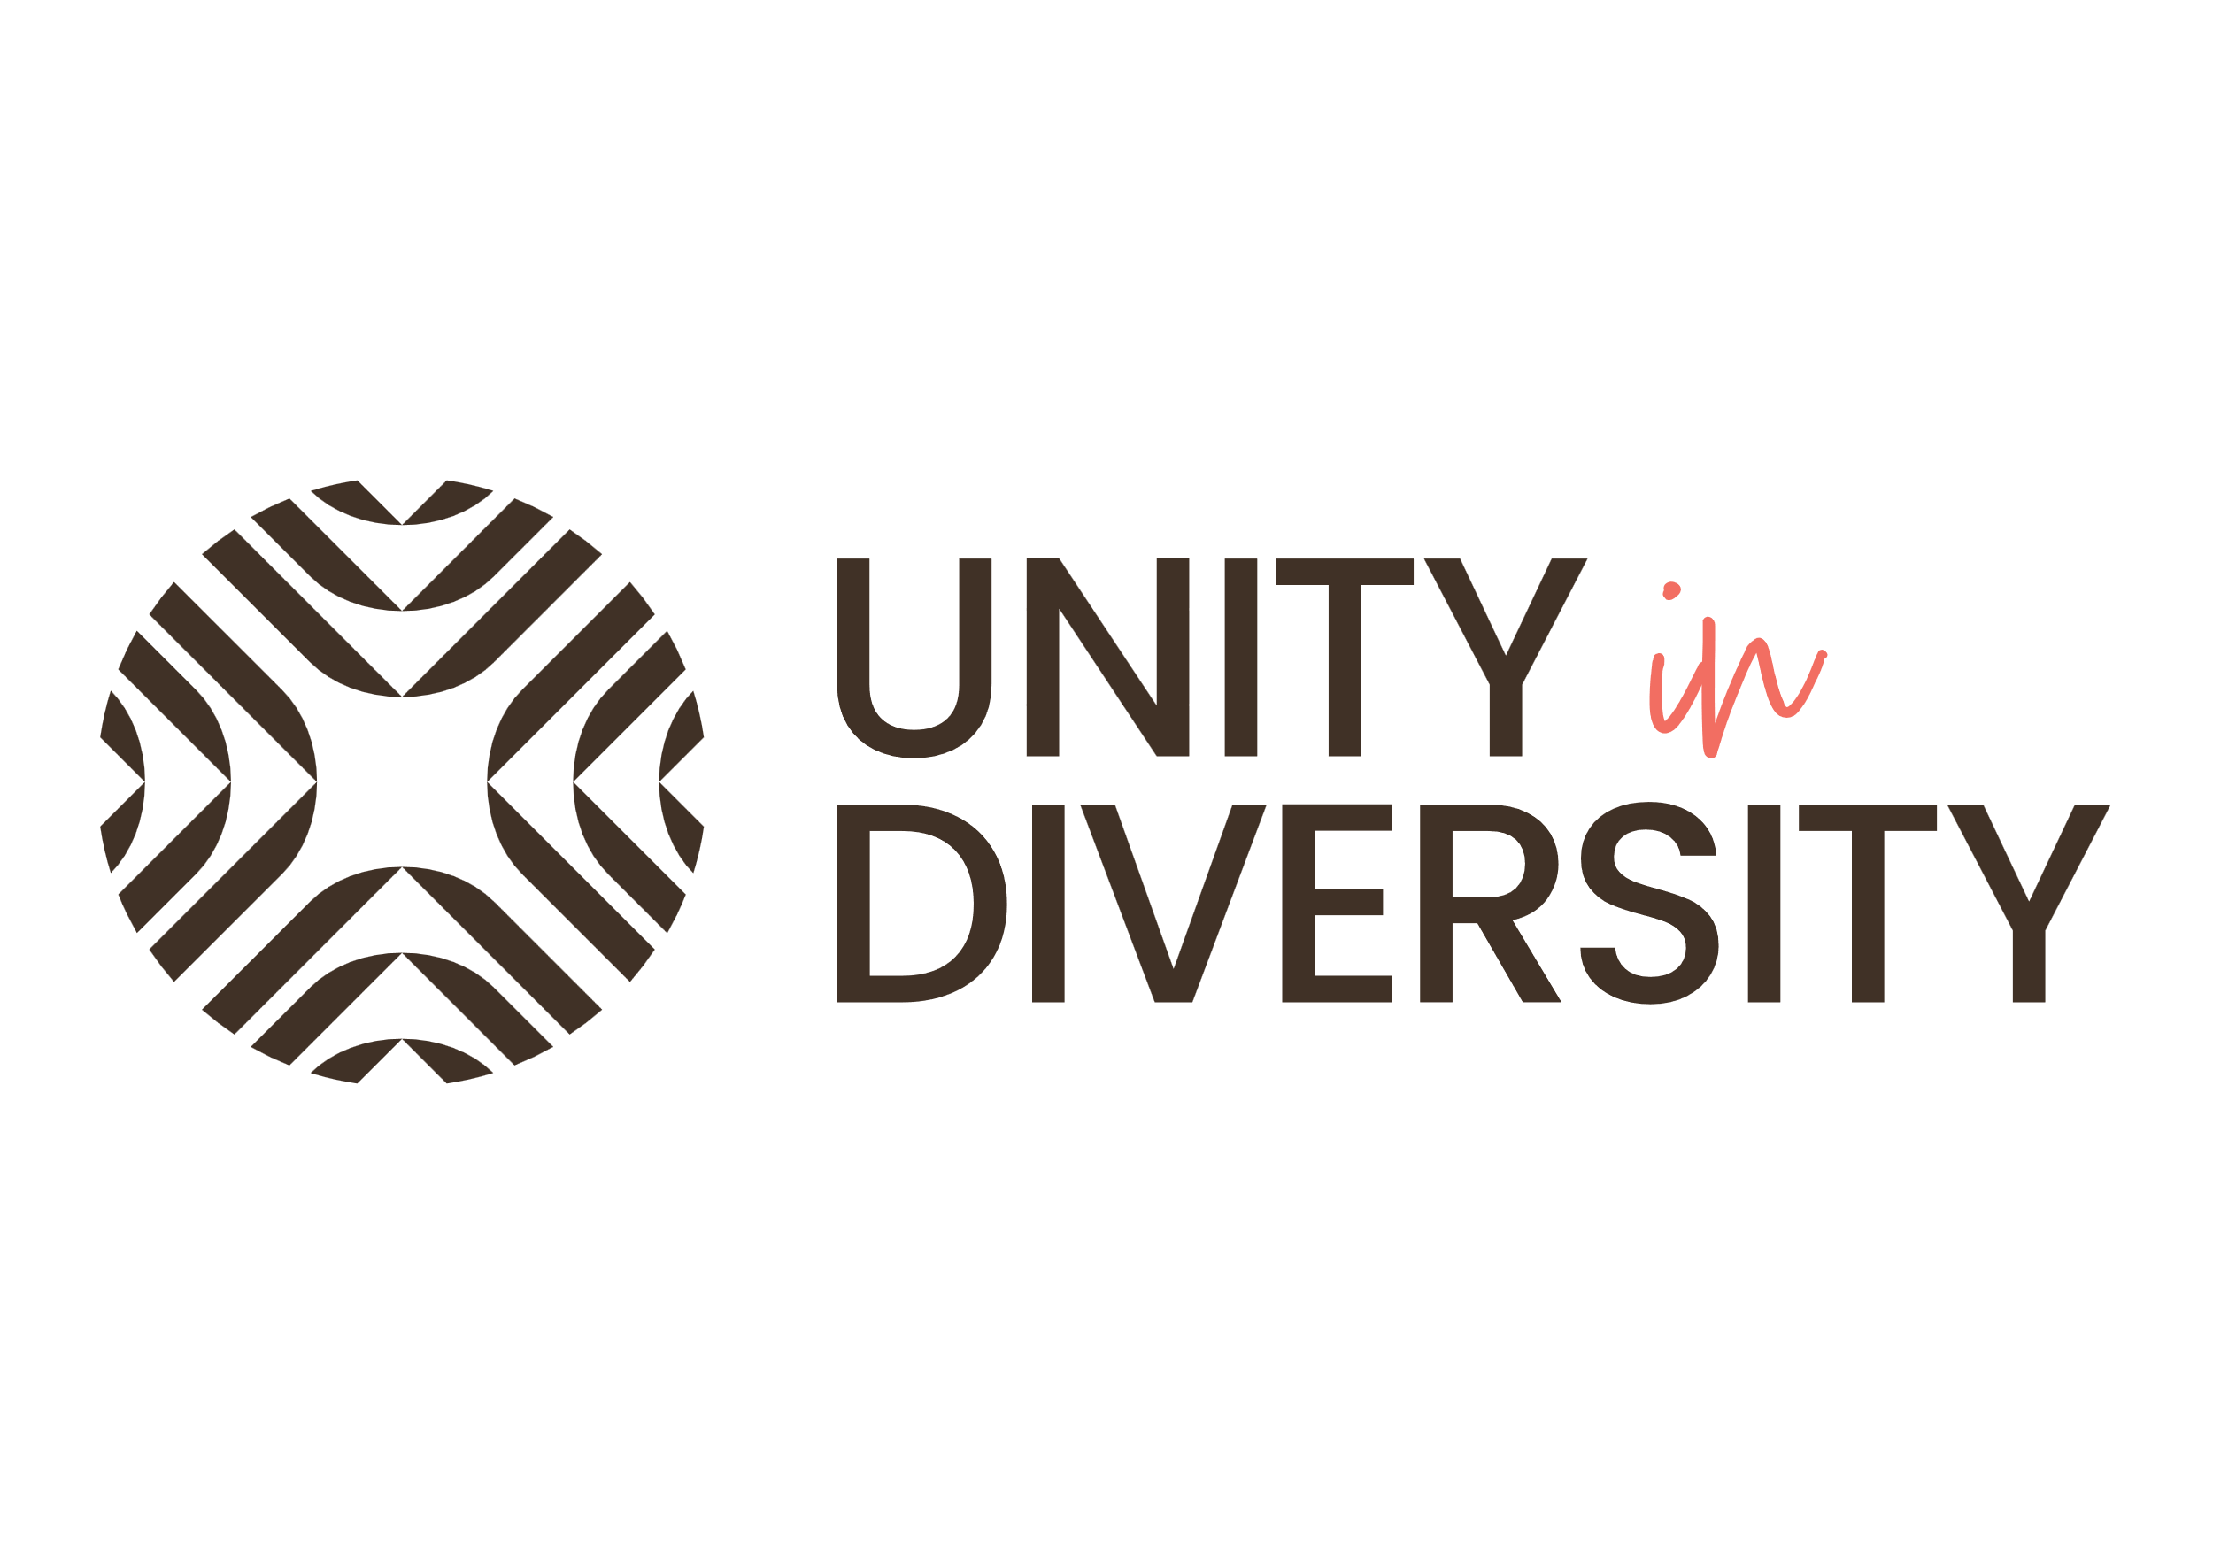
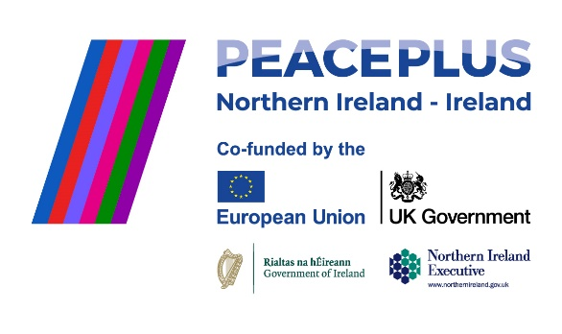
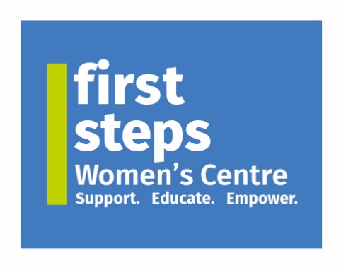

JOB SPECIFICATION
Project Officer
Unity in Diversity Programme
Responsible to: | Programme Manager
Contract type: | Fixed term (aligned to programme end date)
Hours: | 16 hours per week (flexible over 3 days)
Location: | First Steps Women’s Centre, Dungannon – with travel across Mid Ulster – (Magherafelt and Cookstown)
Salary: | £27.3k pro rata (£15.04/hr hour)

Job Purpose
To support the day-to-day delivery of the PEACEPLUS Unity in Diversity programme across Mid Ulster's three main towns (Dungannon, Magherafelt and Cookstown). Working alongside the Programme Manager, the Project Officer will engage with minority communities, migrant workers, refugees and the wider public to promote integration, inclusion and intercultural understanding, contributing to the programme's three-year goal of engaging 500 participants in meaningful community activities.

Programme Context
The Unity in Diversity programme is a three-year PEACEPLUS initiative delivered by First Steps Women's Centre across Mid Ulster. The programme aims to:
- Promote understanding and respect for diversity
- Build capacity within minority communities
- Challenge hate narratives through education and dialogue
- Create sustainable integration pathways for migrant workers and refugees
- Develop community champions who advocate for inclusion
Programme activities include dialogue circles, English language classes, Sanctuary Runners, citizenship exam mentoring, cultural events and other cross-community initiatives.

Key Responsibilities

Programme Delivery
- Coordinate and support the delivery of programme activities, examples include dialogue circles, language classes, running/walking groups, citizenship exam mentoring and cultural events
- Liaise with activity facilitators, partner organisations and community venues to ensure sessions are well-organised and run smoothly
- Assist in recruiting and retaining programme participants, with particular attention to reaching minority and marginalised groups
- Respond to participant enquiries and provide appropriate information and referrals

Administration and Compliance
- Maintain accurate participant records, attendance registers in line with GDPR requirements and funder expectations (PEACEPLUS/SEUPB)
- Assist in preparing progress reports and monitoring returns, evidencing outcomes against programme targets
- Assist with programme communications including social media channels and promotional materials
- Maintain organised filing systems, both digital and paper-based

Stakeholder Engagement
- Build and maintain positive working relationships with statutory, voluntary, community and faith-sector partners
- Support the Programme Manager in developing new partnerships/stakeholder engagement
- Act as a welcoming and culturally sensitive point of contact for participants from diverse backgrounds

Monitoring and Evaluation
- Assist with the collection of participant feedback, case study evidence and testimonials to demonstrate programme impact
- Contribute to mid-term and end-of-programme evaluations
- Track progress towards the programme's 500-participant target and other agreed key performance indicators
- Support the compilation of funder reports with accurate, timely data

Person Specification
Essential Criteria
Criterion | Assessed by
Relevant degree in community development, training, education or a related field. Or equivalent experience of at least 3 years working in this area | Application / Interview
Demonstrable knowledge / experience working with minority ethnic, migrant or refugee communities | Application / Interview
Strong organisational and administrative skills with attention to detail | Application / Interview
Excellent interpersonal and communication skills across diverse audiences | Interview
Good understanding of equality, diversity and inclusion principles | Application / Interview
Ability to work independently and manage a varied workload within a part-time schedule | Interview
Competent in Microsoft Office applications and digital communications tools e.g. canva | Application / Interview
Access to own transport and willingness to travel across Dungannon, Magherafelt and Cookstown | Application
Desirable Criteria
Criterion | Assessed by
Knowledge of monitoring and evaluation frameworks | Application / Interview
Second language relevant to programme communities (e.g. Polish, Portuguese, Romanian, Ukrainian, Arabic, Tetum) | Application
Experience using social media platforms for community engagement and outreach | Application
Understanding of the Mid Ulster context, its diverse communities and cultural landscape | Interview

Values and Behaviours
The Project Officer will be expected to demonstrate the following values in all aspects of their work:
- Respect for diversity – actively valuing difference and treating all individuals with dignity
- Commitment to inclusion – ensuring all participants feel welcome, represented and heard
- Collaborative spirit – working effectively across communities, organisations and disciplines
- Cultural sensitivity – engaging with awareness and empathy across cultural boundaries
- Integrity and accountability – acting transparently and taking ownership of responsibilities

